**CHAPTER-6 Class Room Objective**

**WATER-IMAGE**

**Water-Image:** The reflection of the object, as seen in water, is called its water image. It is the inverted image obtained by turning the object upside down.

**WATER-IMAGE OF CAPITAL LETTERS**

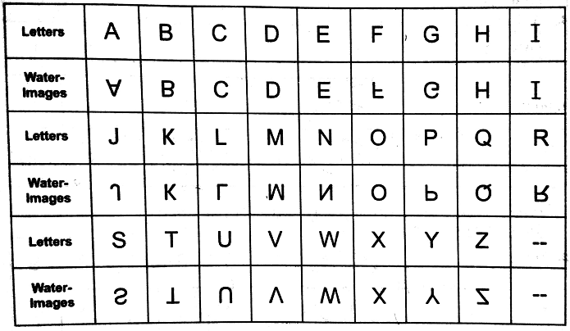

**Remark1:** The letters whose water-images are identical to the letter itself are:

**C, D, E, H, I, K, O, X**

**Remark2:** Certain words which have water-images identical to the word itself are

**KICK, KID, CHIDE, HIKE, COKE, CODE, CHICK**

**WATER-IMAGE OF SMALL LETTERS**

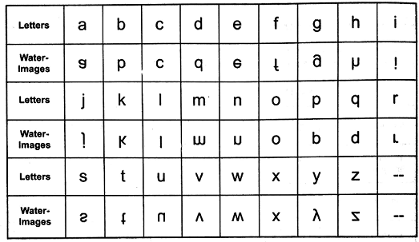

**WATER-IMAGE OF NUMBERS**

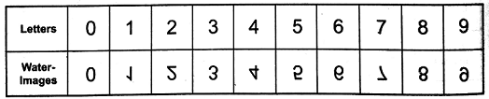

**WATER-IMAGES OF CLOCKS**

There are certain questions in which the positions of the hour-hand and the minute hand of a clock as seen in a water are given. On the basis of the time indicated by the water image of the clock we have to detect the actual time in the clock. In the solution of such questions we use the fact that if an object A is water image of another object B then B is the water image of A. The method of solving such questions would be clear from the following examples.

**Ex1.** Looking into the water, the clock shows 3:20 as the time. The actual time is

a) 8:40 b) 8:30 c) **3:10** d) 3:30

**Ex2.** When seen through a water, a clock shows 6:40. The correct time is

a) 2:30 b) 3:30 c) **11:50** d) 10:30

**Ex3.** By looking in a water, it appears that it is 3:45 in the clock. What is the real time?

a) **2:45** b) 3:30 c) 4:30 d) 6:30

**Ex4.** A clock seen through a water shows quarter past three. What is the correct time shown by the clock?

a) 2:30 b) **3:15** c) 4:30 d) 6:30

**Ex5.** A clock seen through a water shows quarter to three. What is the correct time shown by the clock?

a) 2:30 b) 3:30 c) 4:30 d) **3:45**

|  |
| --- |
| **EXCERCISE** |

**Directions**: In each of the following questions, you are given a combination of alphabets and/or numbers followed by four alternatives a), b), c) & d). Choose the alternative which most closely resembles the water image of the given combination.

**Q1.** DISC



**Q2.** FROG



**Q3.** RECRUIT



**Q4.** US91Q4M5W3



**Q5.** r i s e



**Q6.** b r i d g e



**Q7.** N 4 t Q j 3



**Q8.** A 1 M 3 b



**Q9.** E 8 t 4 e 9 C



**Q10.** a b 4 5 C D 6 7



**Q11.** Question figure

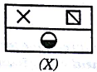

Answer figure

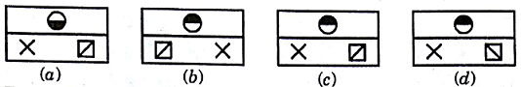

**Q12.** Question figure

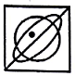

Answer figure

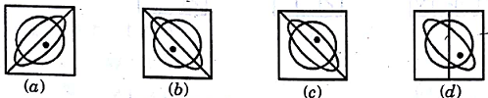

**Q13.** Question figure

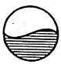

Answer figure

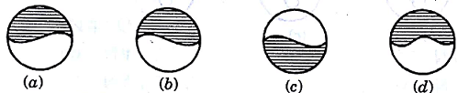

**Q14.** Question figure

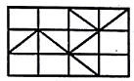

Answer figure

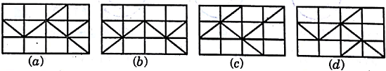

**Q15.** Question figure

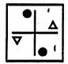

Answer figure

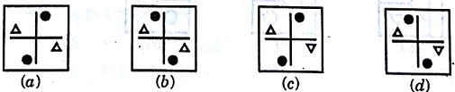

**Q16.** Question figure

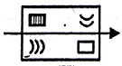

Answer figure

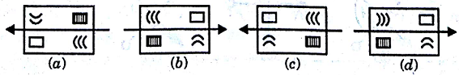

**Q17.** Question figure



Answer figure

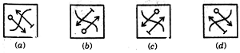

**Q18**. Question figure



Answer figure

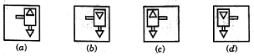

**Q19.** Question figure



Answer figure

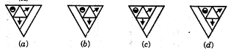

**Q20.** Question figure



Answer figure



